**DAILY ONLINE ACTIVITIES SUMMARY**

|  |  |  |  |  |  |  |  |
| --- | --- | --- | --- | --- | --- | --- | --- |
| **Date:** | 02/07/2020 | | | | **Name:** | Sinchana K N | |
| **Sem & Sec** | IV sem & B section | | | | **USN:** | 4AL18CS83 | |
| **Online Test Summary** | | | | | | | |
| **Subject** | | **-** | | | | | |
| **Max. Marks** | | 30 | | **Score** | | **-** | |
| **Certification Course Summary** | | | | | | | |
| **Course** | Data visualization using tableau | | | | | | |
| **Certificate Provider** | | | Great learning academy | **Duration** | | | 11.5hours |
| **Coding Challenges** | | | | | | | |
| **Problem Statement1:** Write a Java Program minimize the maximum difference between adjacent elements in an array. | | | | | | | |
| **Status: Executed** | | | | | | | |
| **Uploaded the report in Github** | | | | YES | | | |
| **If yes Repository name** | | | | https://github.com/acchu1234sinchana/Lockdown_coding1 | | | |
| **Uploaded the report in slack** | | | | YES | | | |

**Online Test Summary:** No internals conducted today.

**Online Certification Course Summary:** Today I have learnt about Visual Analytics and 7 Step Process and Exploring the Tableau Desktop 10 Interface.

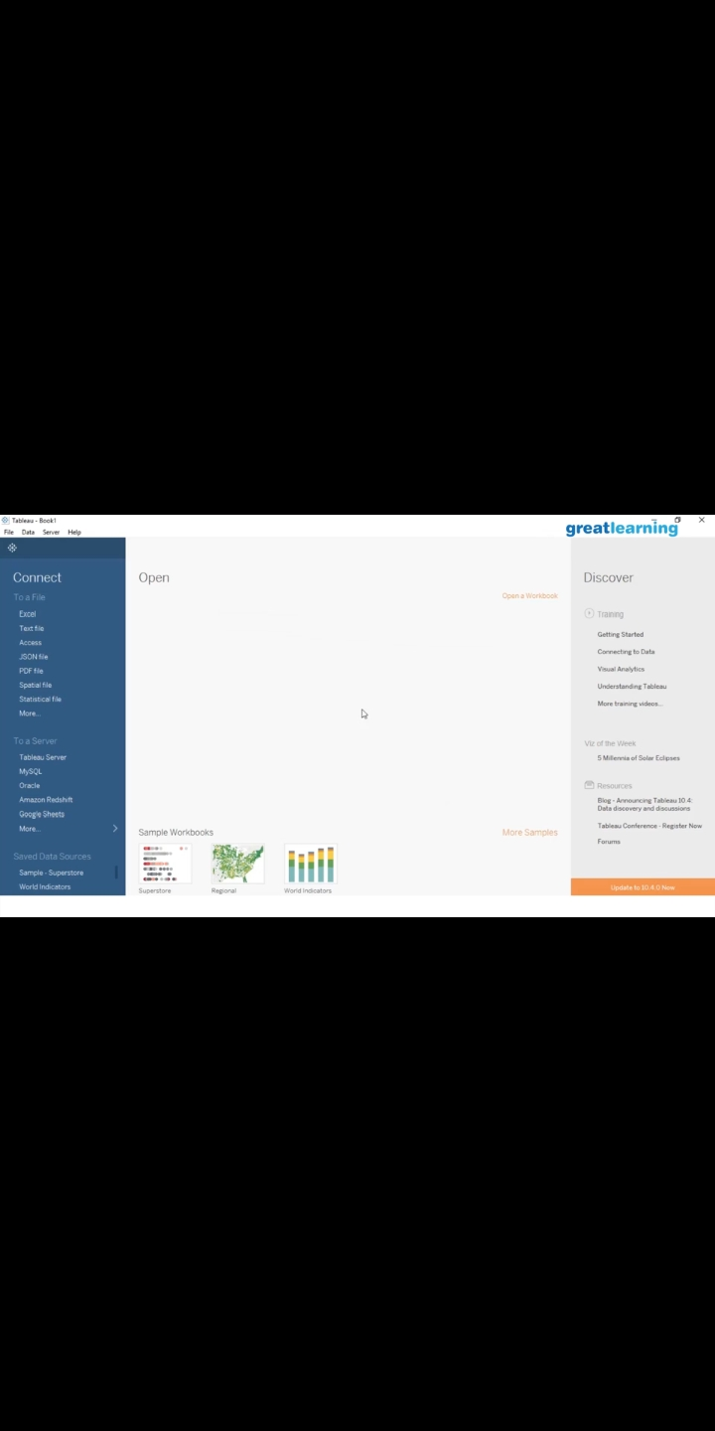

This is the Snapshot of the quiz attempted and grade obtained.

This is the Snapshot of the certificate of completion.

**Online Coding Summary:** Today I had received one program from prof. Shilpa CSE Dept. The program is mentioned above in the coding challenges (pg.01). I have also uploaded it to my Github repository.

This is the Snapshot of my Github repository were I have uploaded the code. File name is Adjacent.java

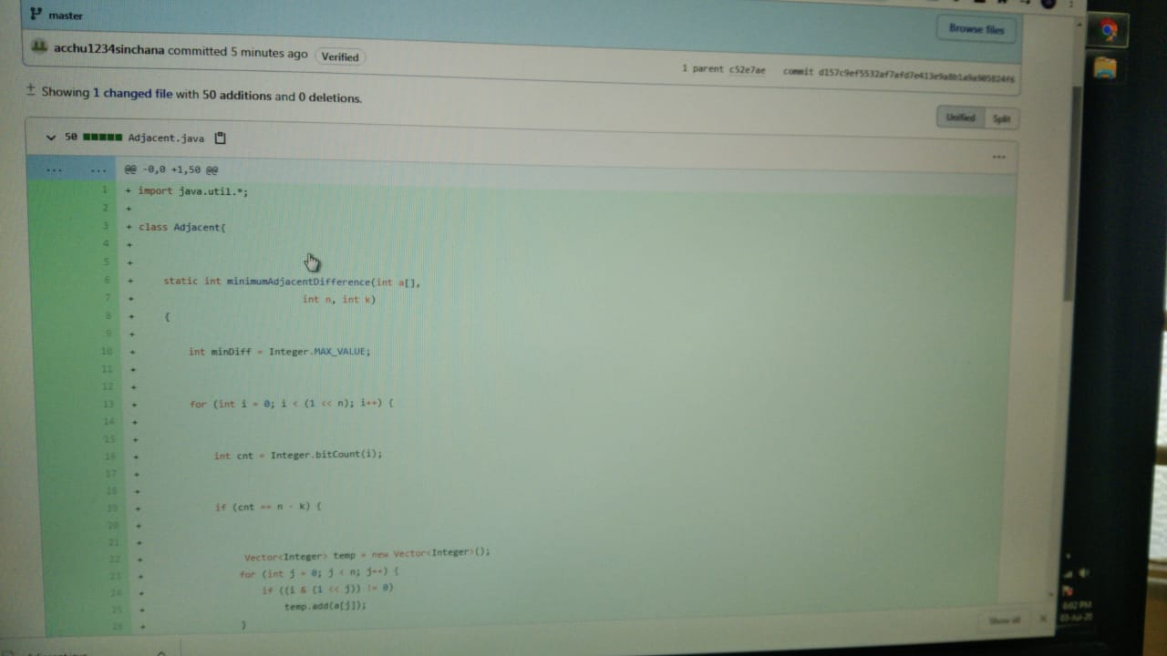

**Online Training:** Today I had attended the online training organized by CSE Department AIET. The training was on C++ programming language done by Prof. Shruthi Shetty J. CSE Dept. After the session the quiz was conducted.

